**WAPT Week 12 OWASP Top 10 Assignment**

Contents

1. Forged Signed JWT 2

2. Frontend Typosquatting 5

3. Kill Chatbot 5

4. Retrieve Blueprint 6

5. Supply Chain Attack 8

6. Unsigned JWT 9

# Forged Signed JWT

# Frontend Typosquatting

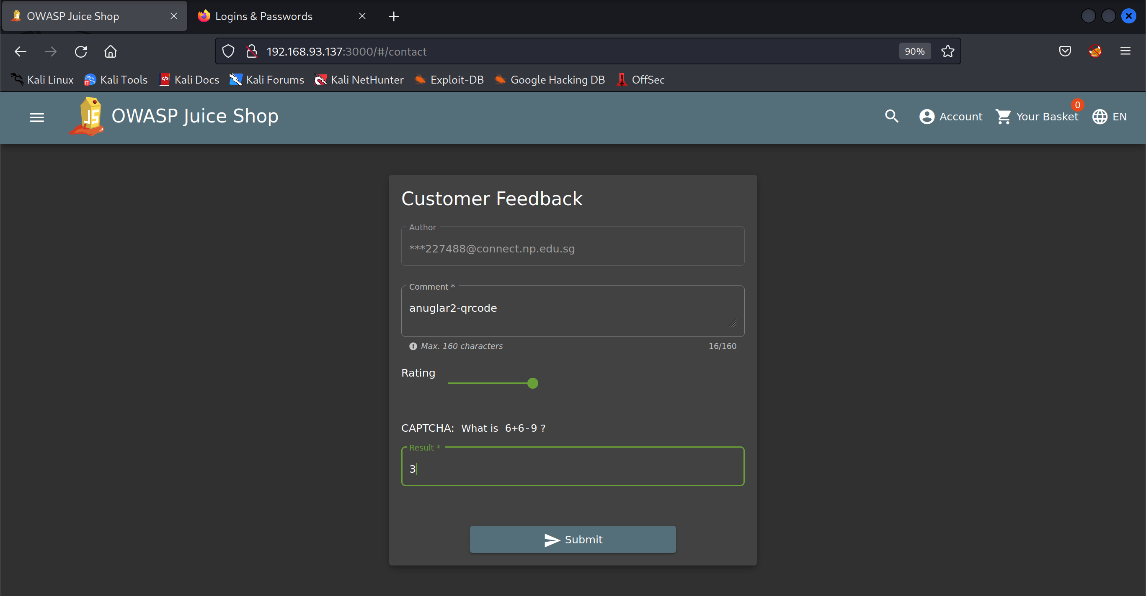

# Kill Chatbot

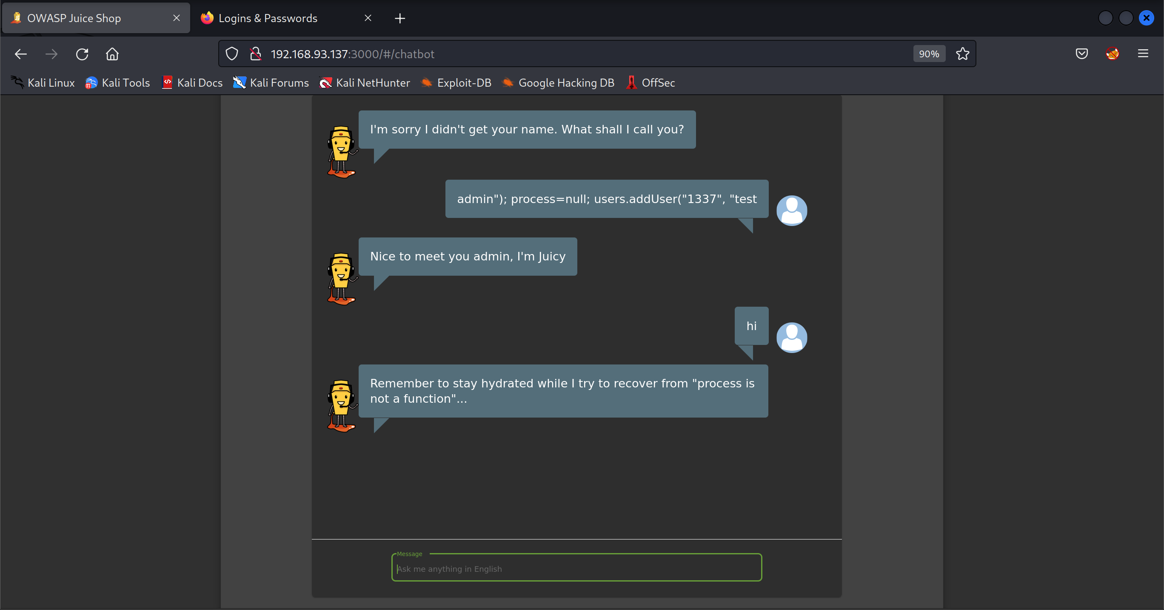

# Retrieve Blueprint

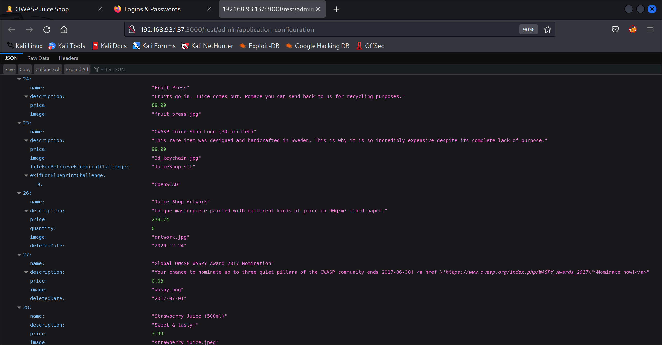

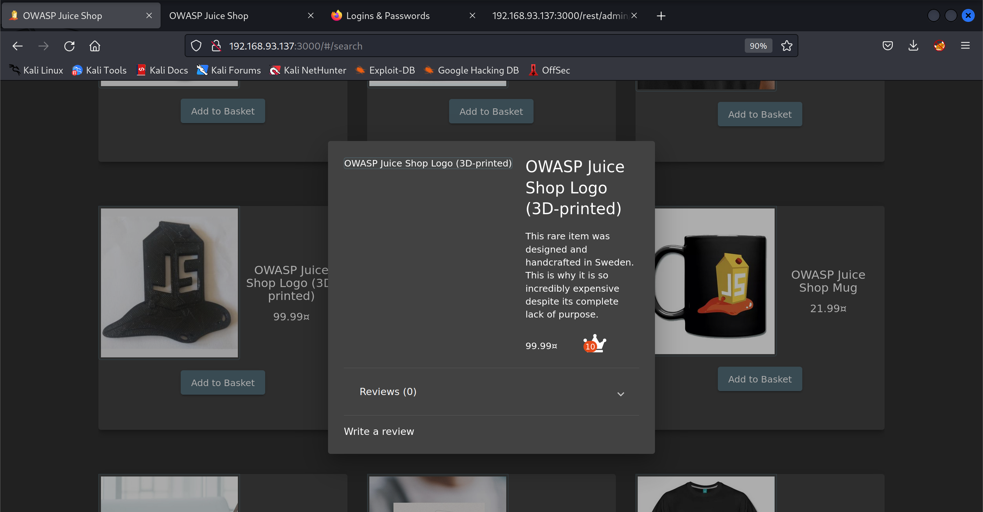

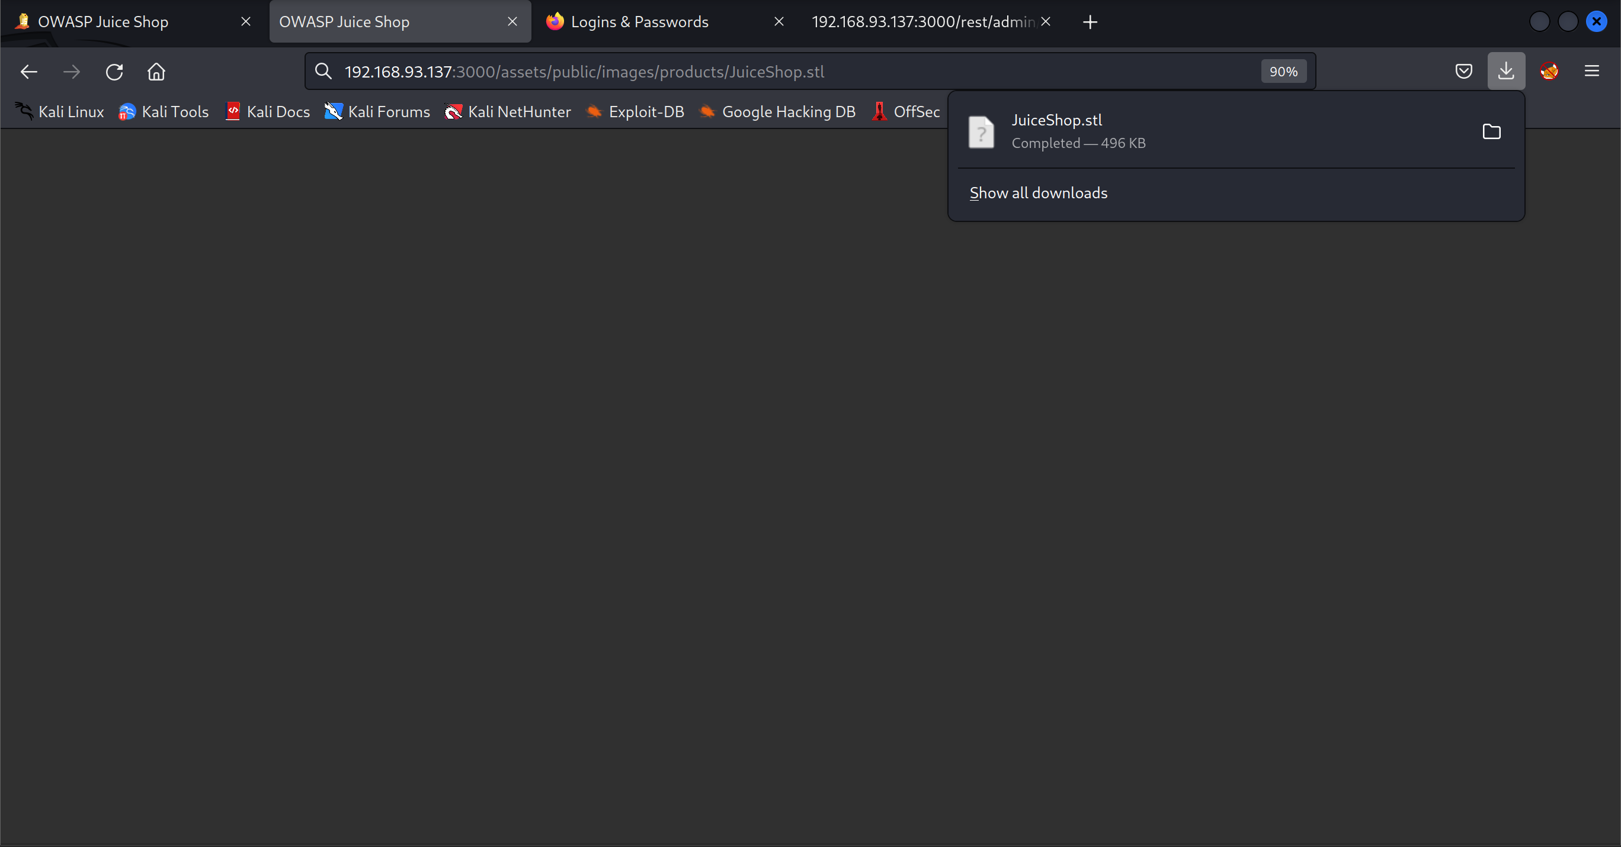

# Supply Chain Attack

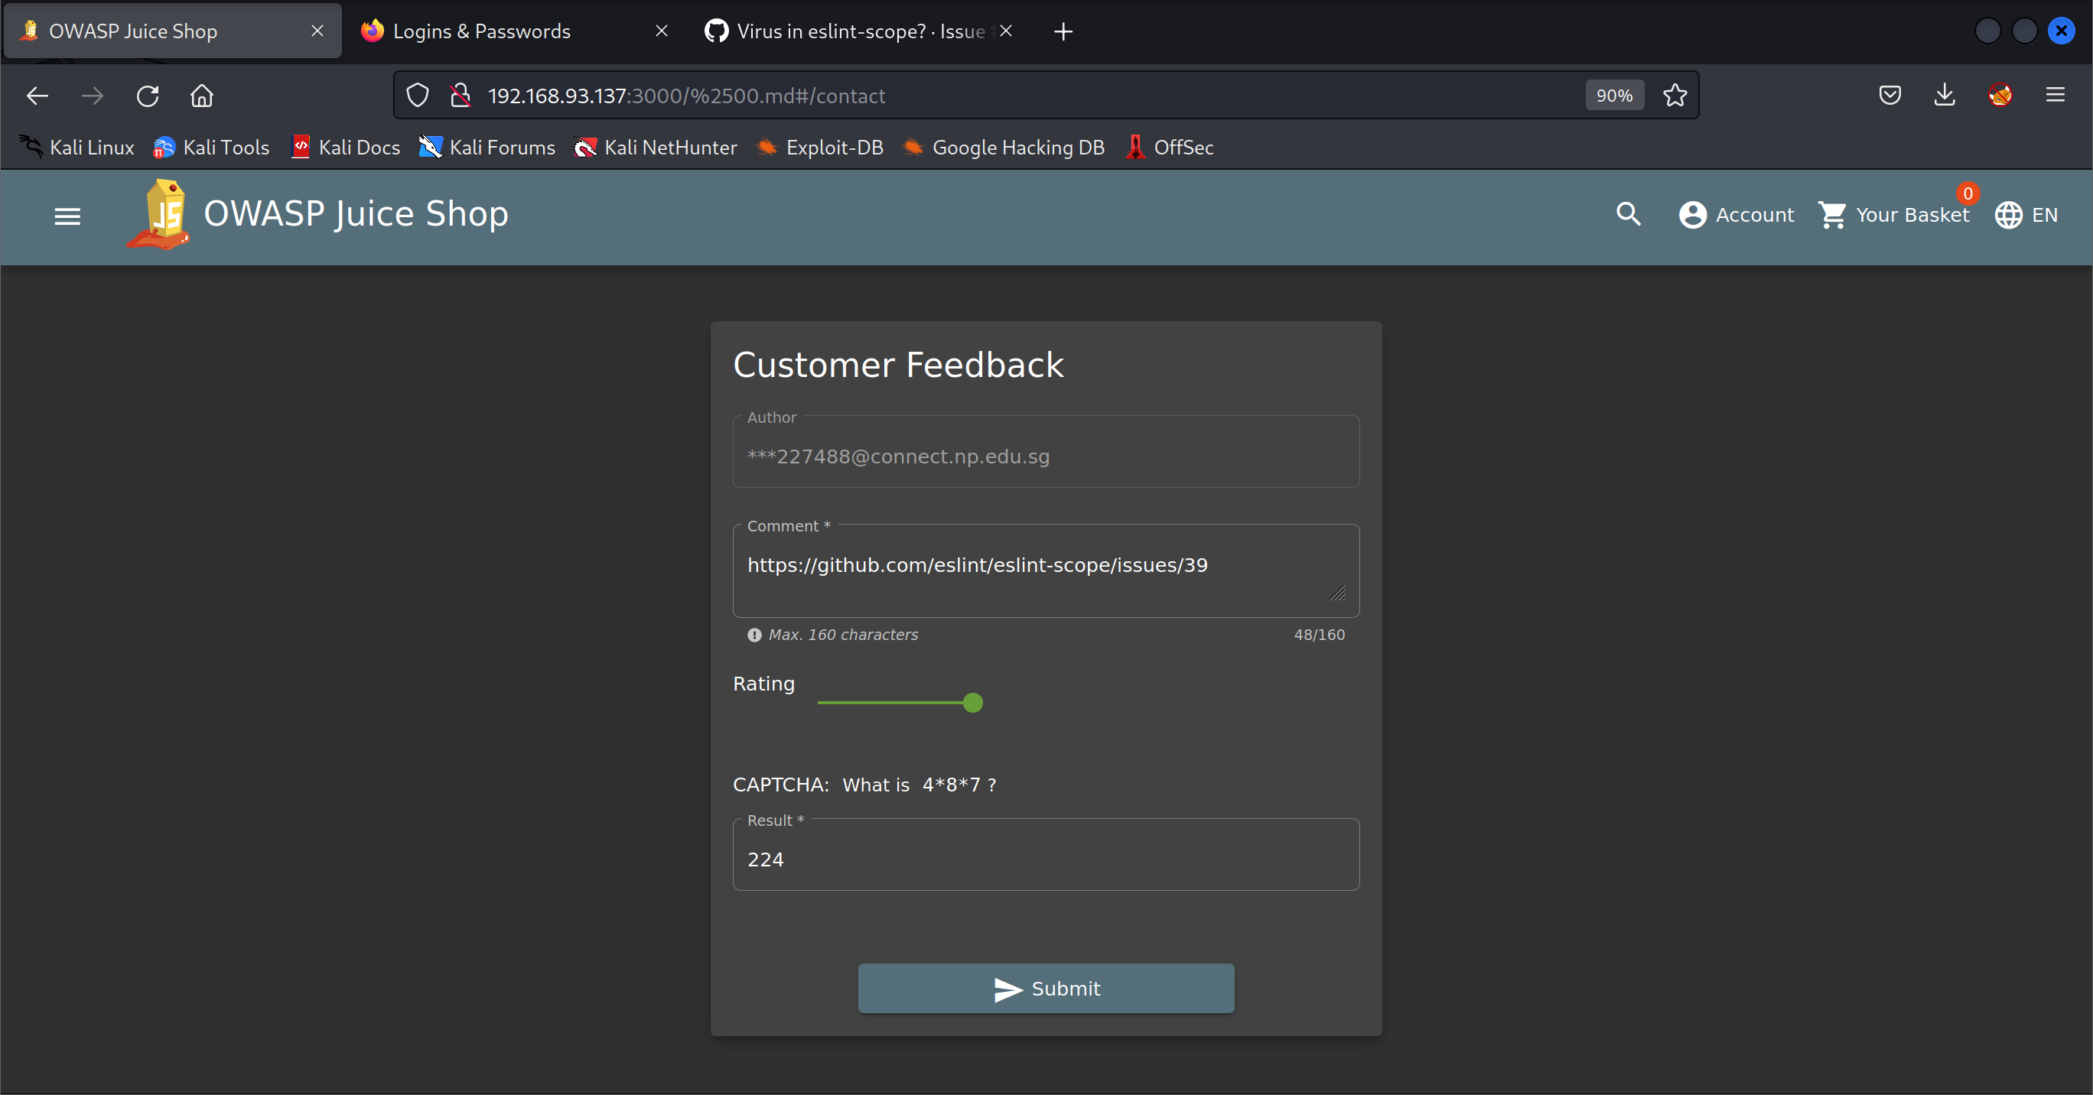

# Unsigned JWT



